Ideation Phase
Define the Problem Statements

Date | 03 October 2026
Team ID | SWTID-2026-6867
Project Name | Streamlining IT Procurement: Automating Standard Laptop Orders with Flow Designer
Maximum Marks | 2 Marks

Customer Problem Statement Template:
In many organizations, employees require standard laptops for their day-to-day work and submit laptop requests through the IT procurement process. These requests may involve approval, task creation, hardware assignment, and laptop configuration activities. When these activities are handled manually, the process can take additional time and may result in delays in creating or assigning configuration tasks to the Hardware team. The customer needs a faster and more reliable way to process standard laptop requests and ensure that configuration activities are initiated after approval. The Streamlining IT Procurement: Automating Standard Laptop Orders with Flow Designer project addresses this problem by using ServiceNow Flow Designer to automate the creation and assignment of a Catalog Task after the laptop request is approved. This helps reduce manual effort, improve task assignment, minimize processing delays, and provide employees with a smoother laptop procurement experience.
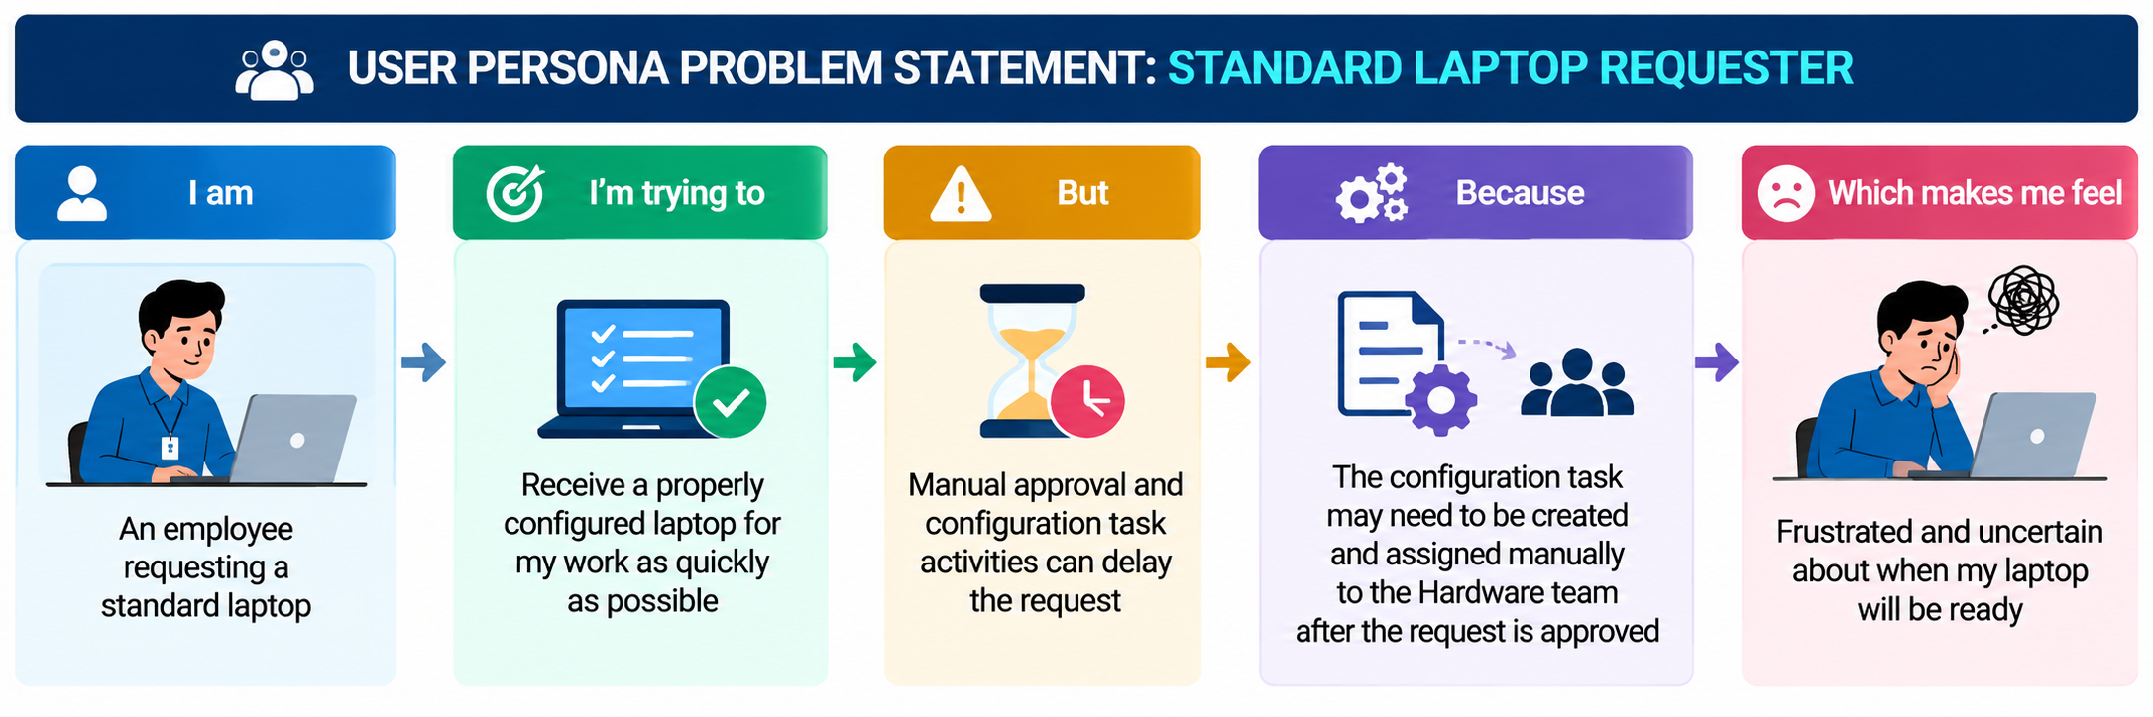
Example:

Problem Statement (PS) | I am (Customer) | I’m trying to | But | Because | Which makes me feel
PS-1 | An employee who requests a standard laptop from the IT department for work-related requirements. | Receive a properly configured laptop as quickly as possible so that I can perform my work without unnecessary waiting. | The laptop request may involve manual approval, task creation, assignment, and configuration activities that can delay the procurement process. | The configuration task may need to be created and assigned manually to the Hardware team after the request is approved. | Frustrated and uncertain because I may have to wait longer for my laptop to be configured and made ready for use.
PS-2 | An IT procurement or Hardware team member responsible for processing standard laptop requests and configuring laptops. | Process approved laptop requests efficiently and ensure that configuration tasks are assigned to the Hardware team on time. | Configuration tasks may have to be created and assigned manually after the laptop request is approved. | The existing process requires repeated manual intervention to create, assign, and track laptop configuration tasks. | Overloaded and concerned about processing delays, missed tasks, and inefficient use of IT resources.

